8 – BIT MULTIPLICATION

# EXP NO:03

# Aim:

# TO write an assembly language program to implement 8-bit Multiplication using 8085 processor.

# ALGORITHM:

# Start the program by loading the first data into the accumulator.

# 2. Move the data to a register.

# 3. Get the second data and load it into the accumulator.

# 4. Add the two register contents.

# 5. Check for carry.

# 6. Store the value of sum and carry in the memory location.

# 7. Halt.

# PROGRAM:

LDA 4500

MOV B,A

LDA 4501

MOV C,A

CPI 00

JZ LOOP

XRA A

LOOP1: ADD B

DCR C

JZ LOOP

JMP LOOP1

LOOP : STA 4502

RST 1

# INPUT:

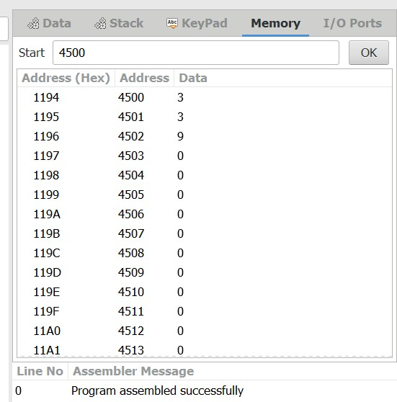

# OUTPUT:

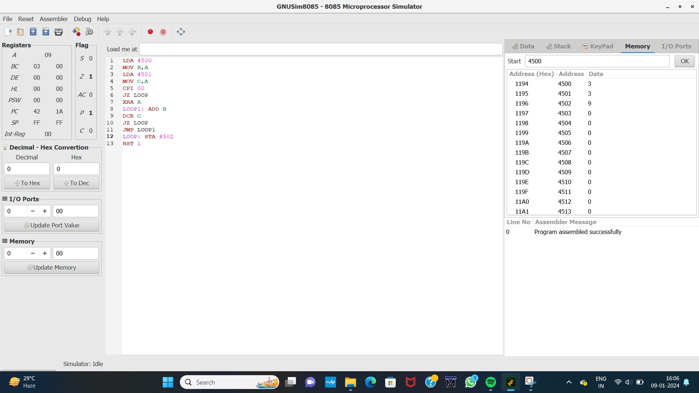

# RESULT:

Thus the program was executed successfully using 8085 processor stimulator.